Project Planning Phase

**Project Planning Template (Product Backlog, Sprint Planning, Stories, Story points)**

|  |  |
| --- | --- |
| Date | 6 Novermber |
| Team ID | PNT2022TMID18742 |
| Project Name | Digital Naturalist - AI Enabled tool for Biodiversity Researchers |
| Maximum Marks | 8 Marks |

Product Backlog, Sprint Schedule, and Estimation (4 Marks)

|  |  |  |  |  |  |  |
| --- | --- | --- | --- | --- | --- | --- |
| **Sprint** | **Functional Requirement (Epic)** | **User Story Number** | **User Story / Task** | **Story Points** | **Priority** | **Team Members** |
| Sprint-1 | Modelling Phase | USN-1 | Data Collecting and digitalizing for analysing | 3 | Medium | K.VAISHNAVI |
| Sprint-1 | USN-2 | Adding more data to avoid overfitting | 2 | Medium | G.HARISH REDDY |
| Sprint-1 | USN-3 | Building a CNN model using the collected data | 5 | High | B.DANUSH |
| Sprint-1 | USN-4 | Evaluating the model to check the accuracy and precision | 3 | High | T.VISHNU KANTH |
| Sprint-2 | Development Phase | USN-5 | Home page Creation – Shows the features of our application | 1 | Low | K.ARAVIND |
| Sprint-2 | USN-6 | Setting up facilities for user to feed the image | 2 | Medium | T.VISHNU KANTH |
| Sprint-2 | USN-7 | Prediction page creation – shows prediction for the user given image | 4 | Medium | B.DANUSH |
| Sprint-2 | USN-8 | Model loading – API creation using flask | 5 | High | G.HARISH REDDY |
| Sprint-3 | Deployment Phase | USN-9 | Integrating UI & backend – Connecting the front end and backend using API calls | 3 | Medium | K.VAISHNAVI |
| Sprint-3 | USN-10 | Cloud deployment – Deployment of application using IBM Cloud | 5 | High | K.VAISHNAVI |
| Sprint-4 | Testing Phase | USN-11 | Functional testing – Checking the scalability and robustness of the application | 5 | High | K.ARAVIND |

Project Tracker, Velocity & Burndown Chart: (4 Marks)

|  |  |  |  |  |  |  |
| --- | --- | --- | --- | --- | --- | --- |
| **Sprint** | **Total Story Points** | **Duration** | **Sprint Start Date** | **Sprint End Date (Planned)** | **Story Points Completed (as on Planned End Date)** | **Sprint Release Date (Actual)** |
| Sprint-1 | 13 | 6 Days | 24 Oct 2022 | 29 Oct 2022 | 13 | 29 Oct 2022 |
| Sprint-2 | 12 | 6 Days | 31 Oct 2022 | 05 Nov 2022 | 12 | 05 Nov 2022 |
| Sprint-3 | 8 | 6 Days | 07 Nov 2022 | 12 Nov 2022 | 8 | 12 Nov 2022 |
| Sprint-4 | 10 | 6 Days | 14 Nov 2022 | 19 Nov 2022 | 10 | 19 Nov 2022 |

Velocity:

Average Velocity = 61/24 = 2.51

Burndown Chart:

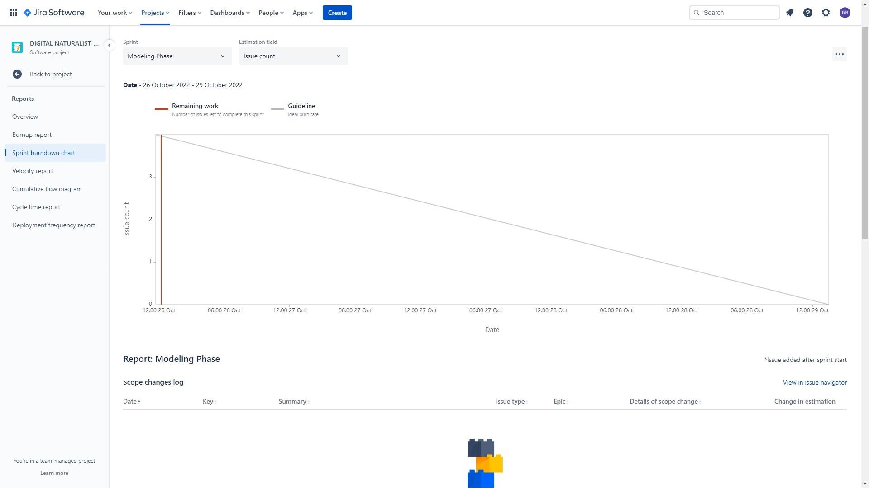

Roadmap:

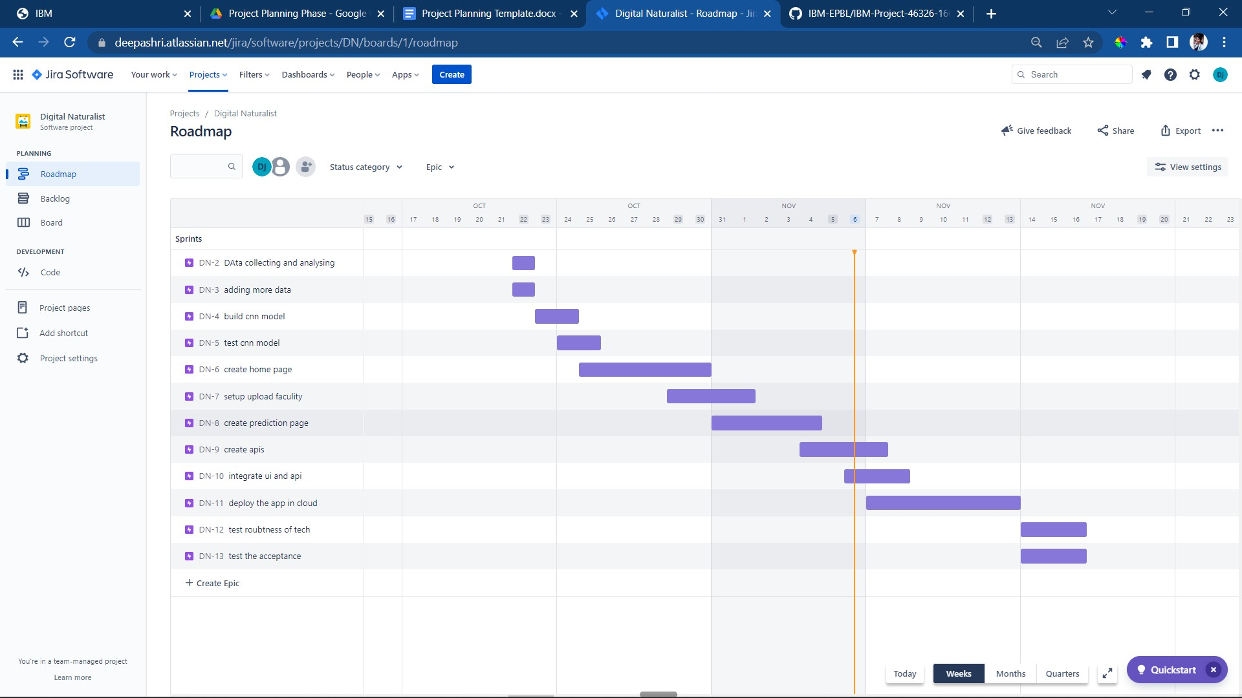

Backlog:

